# MongoDB assignment-1

## Inserting data

use user

db.users.insertMany([

{

username: "alex_p",

email: "alex.p@example.com",

age: 28,

country: "USA",

last_login: ISODate("2023-10-25T10:00:00Z"),

followers: 1200,

interests: ["programming", "hiking", "music"],

profile: { theme: "dark", bio: "Software developer and nature enthusiast." },

devices: [

{ type: "mobile", os: "Android", last_seen: ISODate("2023-10-25T09:55:00Z") },

{ type: "desktop", os: "Windows", last_seen: ISODate("2023-10-24T15:30:00Z") }

]

},

{

username: "jane_doe",

email: "jane.d@workplace.com",

age: 34,

country: "Canada",

last_login: ISODate("2023-11-01T12:30:00Z"),

followers: 850,

interests: ["travel", "photography", "music"],

profile: { theme: "light" },

subscription: { tier: "premium", start_date: ISODate("2023-01-01T00:00:00Z") }

},

{

username: "sam_g",

email: "sam.g@example.com",

age: 22,

country: "UK",

last_login: ISODate("2023-09-15T18:45:00Z"),

followers: 2500,

interests: ["gaming", "streaming"],

profile: { theme: "dark", bio: "Pro gamer and streamer." },

devices: [

{ type: "desktop", os: "Windows", last_seen: ISODate("2023-09-15T18:40:00Z") }

]

},

{

username: "chris_b",

email: "chris.b@inbox.com",

age: 45,

country: "Australia",

last_login: ISODate("2023-10-30T05:00:00Z"),

followers: 50,

interests: ["gardening", "cooking"],

profile: { theme: "light", bio: "Loves the outdoors." }

},

{

username: "maria_s",

email: "maria.s@example.com",

age: 31,

country: "Germany",

last_login: ISODate("2023-11-02T20:00:00Z"),

followers: 1800,

interests: ["art", "history", "travel"],

profile: { theme: "dark", bio: "Museum curator." },

subscription: { tier: "premium", start_date: ISODate("2022-06-15T00:00:00Z") }

},

{

username: "another_user",

email: "another@example.com",

age: 29,

country: "USA",

followers: 95,

interests: ["music", "programming"],

profile: "Profile setup pending"

}

])

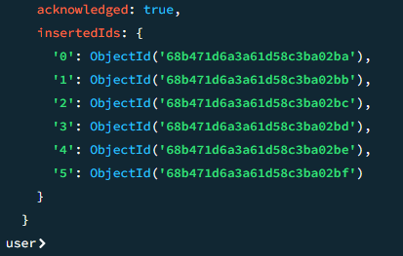

## Questions

### Find users older than 30, but only show their username and country.

db.users.find({ age: { $gt: 30 } }, { username: 1, country:1, _id:0 })

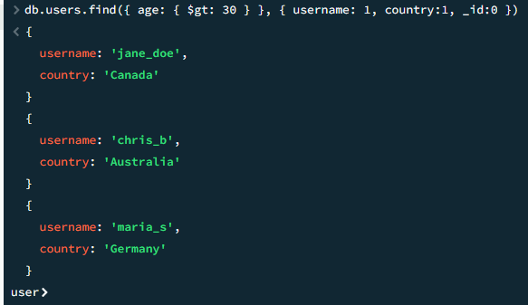

### Find users whose follower count is less than or equal to 100.

db.users.find({ followers: { $lte: 100 } })

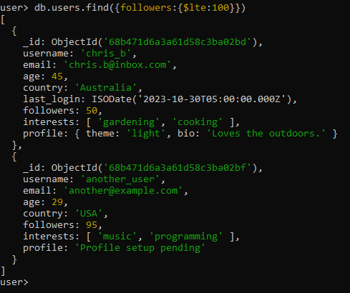

### Find all users from 'USA' or 'Canada'.

db.users.find({ country: { $in: ["USA", "Canada"] } })

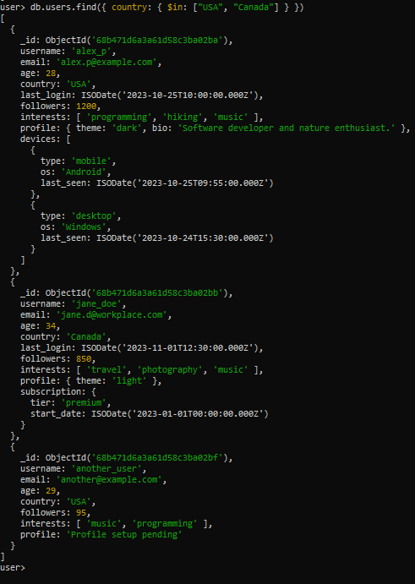

### Find all users who are NOT from 'USA' or the 'UK'.

db.users.find({ country: { $nin: ["USA", "UK"] } })

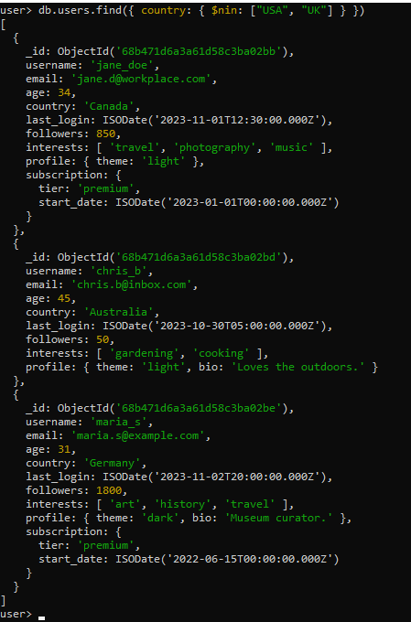

### Find users who are from the 'USA' AND have more than 1000 followers.

db.users.find({ country: "USA", followers: { $gt: 1000 } })

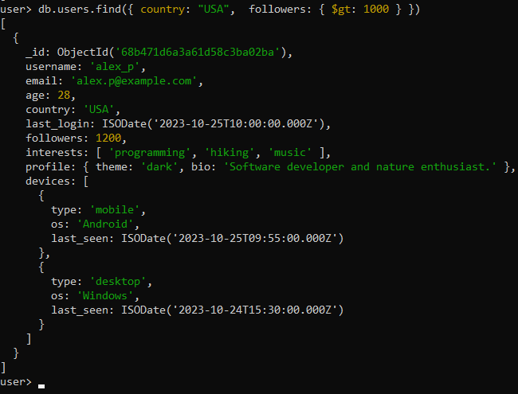

### Find users who have more than 2000 followers OR are from 'Australia'.

db.users.find({$or: [{ followers: { $gt: 2000 } },{ country: "Australia" }]})

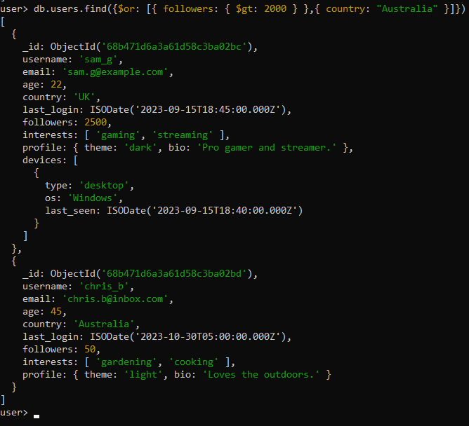

### Find all users who have a subscription field.

db.users.find({ subscription: { $exists: true } })

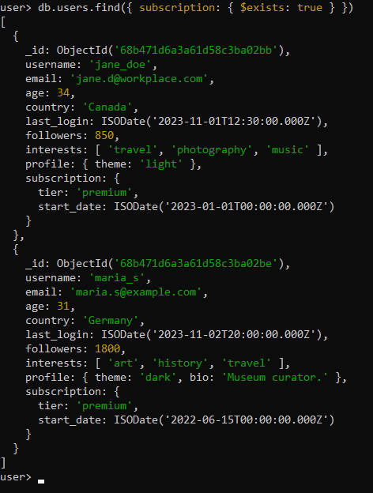

### Find users whose profile field is a string, not an embedded document.

db.users.find({ profile: { $type: "string" } })

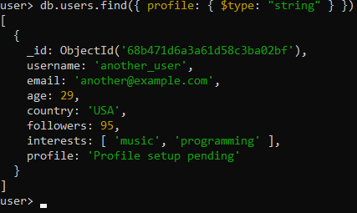

### Find users who are interested in both 'travel' AND 'music'.

db.users.find({interests: { $all: ["travel", "music"] }})

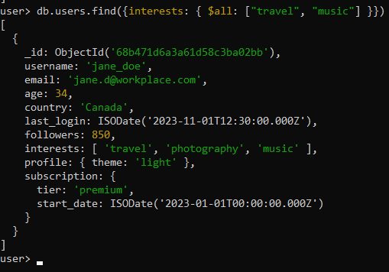

### Find users who have used a 'mobile' device since October 1st, 2023.

db.users.find({"devices.type": "mobile", "devices.last_seen": { $gte: ISODate("2023-10-01T00:00:00Z") }})

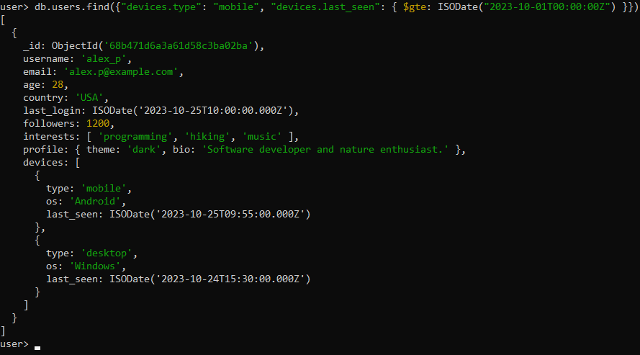

### Find all users whose email address ends with '[workplace.com](http://workplace.com)'.

db.users.find({ email: /workplace\.com$/ })

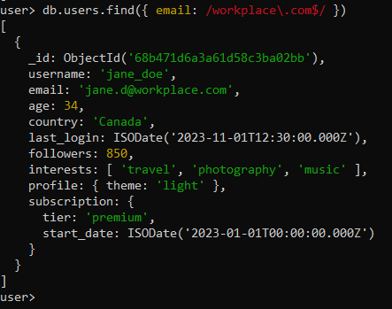

### For user sam_g, add 50 followers and add a new interest 'coding'.

db.users.updateOne({ username: "sam_g" }, { $inc: { followers: 50 }, $push: { interests: "coding" }});

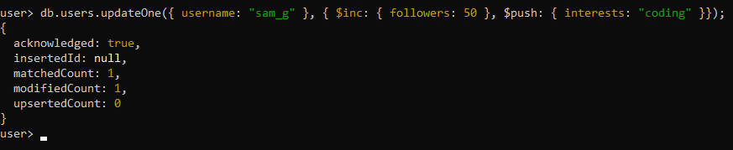

### For all users from the 'USA', rename the followers field to follower_count.

db.users.updateMany({ country: "USA" }, { $rename: { "followers": "follower_count" } })

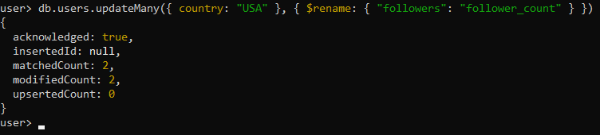

### Attempt to update user new_user; if they don't exist, insert them with default data.

db.users.updateOne(

{ username: "new_user" },

{

$setOnInsert: {

username: "new_user",

email: "new@example.com",

age: 25,

country: "Unknown",

followers: 0,

interests: [],

profile: "Default profile"

}

},

{ upsert: true }

)

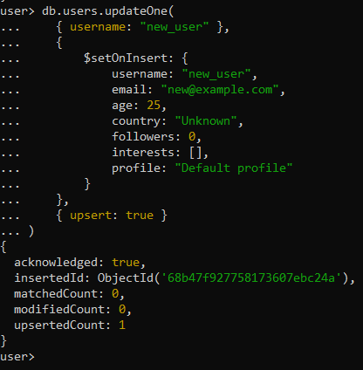

### Delete all users who have not logged in (*hint: the last_login field does not exist*).

db.users.deleteMany({ last_login: { $exists: false } })

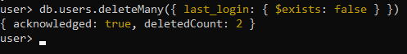

### Find users from the 'USA' who are either younger than 25 OR have more than 1500 followers.

db.users.find({country: "USA",$or: [{ age: { $lt: 25 } },{ followers: { $gt: 1500 }}]})



### Find all users who have a 'desktop' device that runs 'Windows'.

db.users.find({ "devices": { $elemMatch: { type: "desktop", os: "Windows" }}})

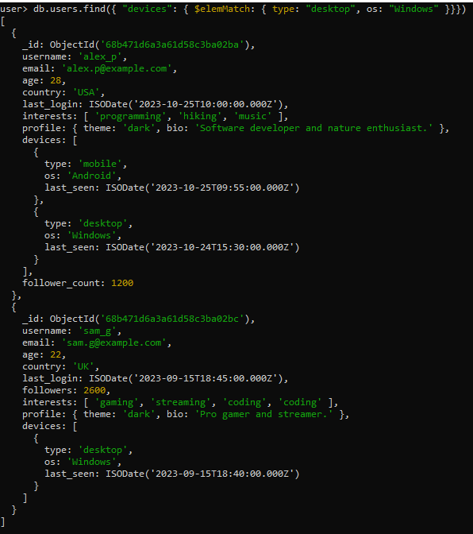

### Update all users with a 'dark' theme profile by adding a pro_user: true flag.

db.users.updateMany( { "profile.theme": "dark" }, { $set: { pro_user: true }})

